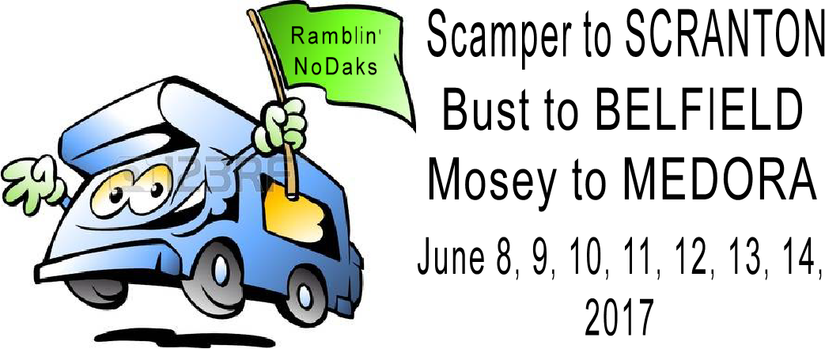

We will be parking at Meier’s shop west of Scranton. (8609 136th Ave SW, Scranton). This is located 3 miles W of Scranton or 10 miles E of Bowman on Hwy US 12. The best route from Dickinson is to go S on Hwy 22 to Hwy 12.

There will be a limited amount of 20-amp electricity and rural water available. If you want electricity, you MUST bring at least a 100’ extension cord.

--------------------------------------------------------------------------------------------------------------------------------------------------

Rally Registration: PLEASE SEND IN YOUR REGISTRATION BY May 31st!

Name: _____________________________________________________________________

Rally Fee – per coach -------------------------------------------------------------- $5.00

3 breakfasts in Scranton - $9.00 X ________ people = -------------------- ____________

Saturday night supper – $15.00 X ________ people = --------------------- ____________

Mon supper and Wed breakfast (in Belfield) - $9.00 X _________ = -- ____________

Total -------------------------------------------------------------------------------------- ____________

Please make checks payable to:
Ramblin’ NoDaks

Please mail to: John and Pam Meier
9605 133rd Ave SW
Scranton, ND 58653

