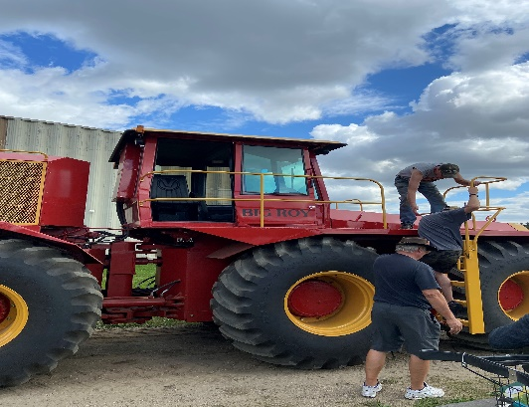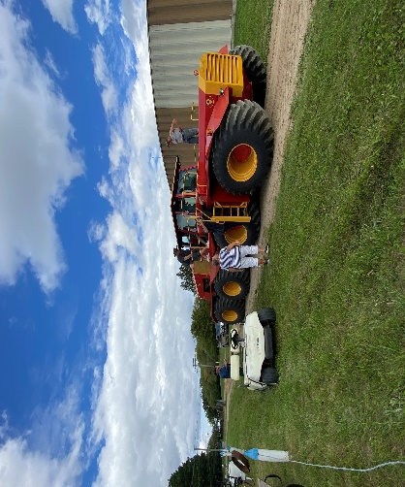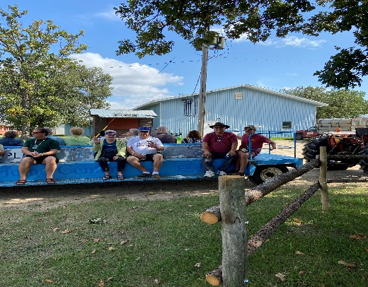
The CANADIAN NORTHERN LIGHTS
No Host FALL RALLY
August 31st – September 4^{th,} 2023
Austin, Manitoba
Three Creeks Campground

Please book your own sites on-line at www.campreservations.ca/campground/three-creeks-campground
We are trying to book sites in the area of 186-195 and also 224-233 which keeps most of our members in one large area and close to the club tents.

Weekend costs: $10.00 per coach

**Coffee in mornings will only be provided in Club tents
Thursday | Arrival of RV ‘s
Friday | **Breakfast and Lunch on your own  3:59 pm Happy Hour  5:30 pm Potluck – Bring your own meat to grill PLUS a dish to share
Saturday | 8:00 – 10:00 am – Pancakes/Coffee  10:00-11:00 am - Brian Little speaking on FMCA Benefits  Lunch on your own  3:59 pm Happy Hour  5:30 pm Bring your own meal (corn on the cob and butter will be provided)  Evening entertainment by the Manitoba Olde Tyme and Bluegrass Society.
Sunday | **Breakfast on your own  9:00 am Chapter meeting – Election of Officers  Lunch on your own  3:00 pm ……. Winnipeg Blue Bombers football game  Bring snacks to share and BYOB
Monday | Departure

