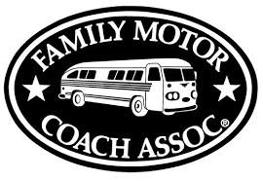
The Ramblin’ NoDaks
MEMBERSHIP APPLICATION
Date____________ FMCA #_________________

Year Joined FMCA_________

Name(s)___________________________________________________________

Mailing Address (summer) ___________________________________________

City, State, Zip_____________________________________________________

Mailing Address (winter)_____________________________________________

City, State, Zip_____________________________________________________

Phone (his)_________________________ (hers)_________________________

Email address_______________________________________________________

Birthday: (his)_____________ (hers)_____________ Anniversary_____________

Previous or current occupation__________________________________________

Hobbies: __________________________________________________________

Type of RV: (please circle one) motorhome 5th wheel travel trailer other

Make____________________ Model____________________ Length _________

How did you hear about us? __________________________________________________________________
Ramblin’ NoDaks website: www.ramblinnodaks.com

Annual membership dues are:
$20.00 for new members and $15.00 yearly thereafter.
Make checks payable to: Ramblin’ NoDaks and send to:
Sandy Eckenrode, Secretary
1536 Country Lane
Bismarck, ND 58503-0821
Phone: 701-426-7757 e-mail: dsecken@bis.midco.net

