Ramblin Nodaks
July 2019
Rugby Rally was a great success!

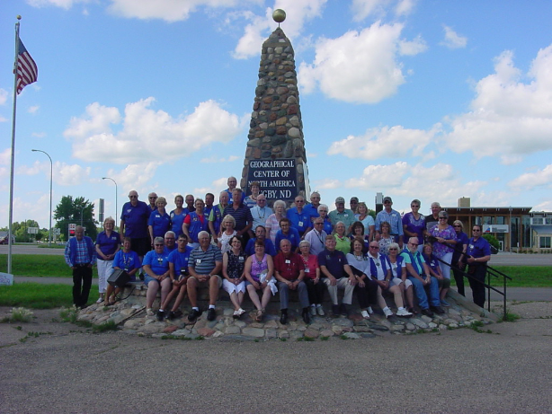
The Pierce County Tribune (Rugby, N.D.), June 29, 2019

Ramblin’ NoDaks coming in July

By Bryce Berginski
Tribune Reporter
For three days in July, the Pierce County Fairgrounds will be home to several motorhomes and trailers. An estimated 35 motor homes and towable trailers, ringing anywhere from 70 to 80 people will come to the fairgrounds July 11-14 to celebrate the 25th anniversary of the Ramblin’ NoDaks chapter of the FMCA (Family Motor Coach Association). According to chapter president Gene Grimm, of Hickson, an evening program will be held at Dakota Farms in which chapter members will eat, “re-live some of the memories of the last 25 years,” and have a dance with music provided by the Spin Doctor. Other events during the visit will include a business
meeting; club activities; and tours of various area sites, including the Prairie Village Museum, the Wind Farm, the Victorian Dress Museum and Towner’s Gunter Honey factory. According to Grimm, planning for the event has “been under way for a
year.” The Ramblin’ NoDaks chapter has members from the Dakotas, Minnesota,
Nebraska and the Canadian provinces of Saskatchewan and Manitoba. The chapter was formed when the FMCA’s International office in Cincinnati, Ohio, contacted members living in and near North Dakota to gauge interest in forming a local chapter. “That was a bit over 25 years ago, and the rest is history,” said Grimm. From May to September, Ramblin’ NoDaks members participate in three day rallies primarily in North Dakota, but also in Canada and South Dakota. Grimm said the rallies include touring local attractions and, when possible, correspond rallies with local celebrations and special events. In the winter, members staying in North
Dakota gather for a Christmas party. Other groups of members have lunches in Texas and Arizona during the winter. “If you enjoy people and the RV lifestyle,” said Gimm, “it is likely that you would enjoy membership in the Ramblin’ NoDaks. In
June, the Ramblin’ NoDaks paid a visit to the Dale &Martha Hawk Museum
Near Wolford. The FMCA will also hold its 100th International Convention at the State
Fair Park in Minot on Aug. 14-17. The organization expects approximately 3,500 RVs
at the convention.

The below article will appear in about a month in the FMCA’s Family RVing magazine.
Ramblin’ NoDaks Celebrates 25 Years
Rugby, ND – the Geographical Center of North America
By Gene Grimm, F365986, President, Ramblin’ NoDaks
July 11-14, 2019

The heavy rains that for days had covered much of North Dakota subsided and provided the Ramblin’ NoDaks with glorious sunny days during the rally held in observance of 25th years as an FMCA affiliate. The Rugby Fairgrounds was a great facility. The building we used for our meals, meeting, and social programs provided shelter from the hot summer sun; was furnished with an excess of tables and chairs; had modern restrooms with showers; and was well lighted, quiet, and secure. Despite the large event turn-out, everyone had access to 50-amp power.
Wednesday’s extra-early arrivals (12 RVs filled with smiling faces) were treated to free ice cream and a pleasant and relaxing concert in a city park on Wednesday evening.
As additional RVs arrived throughout Thursday, many explored local restaurants and city highlights. In the evening, card bingo provided a chance to recoup some of the money spent during the daylight exploratory visits.
Most would agree that the highlight tour took place on Friday afternoon – the Heartland Bison Ranch tour. Upon arrival at the ranch, the operators split our group into three segment tours which included:
1 A wagon ride into the midst of a bison herd.

2 A short walk to see a small herd of NOKOTA horses (a very unique North Dakota horse breed descended from herds owned by Chief Sitting Bull’s Sioux Tribe and used at the Battle of the Little Big Horn). Wild herds of Nokotas can be spotted free ranging in the south unit of the Theodore Roosevelt National Park near Medora, ND.
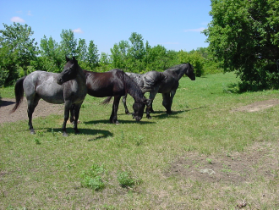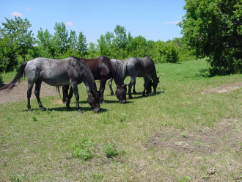
3 An archeological display unearthed on the Heartland ranch that included Indian arrow heads and other relics left behind by early people (and animals) who had passed through the region.
The Heartland Ranch is family owned. Lee & Rebecca Leier and their son Kevin and his wife Anne have owned and operated the Ranch since 1996. Kevin and Anne who led the tour were extremely well versed and provided extremely educational dialogue. They treated the visitors as if we were royalty.
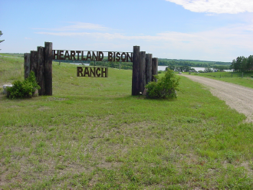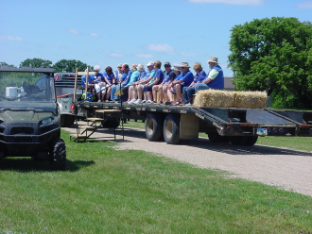
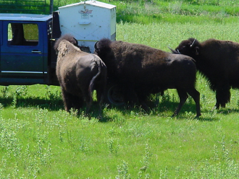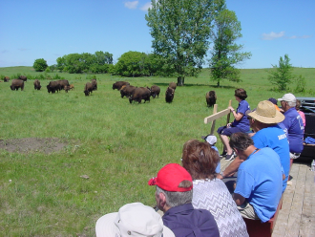
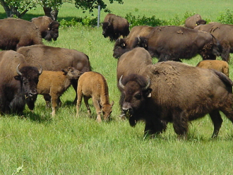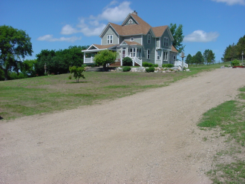
Midwest President Gary and First Lady Glenda Milner were with us for the entire event. They spent meaningful time with each attendee. They were there to assist with each and every task that needed to be done. On Friday evening, Gary and Glenda presented mini-seminars on the FMCA benefits package and on the FMCA University. Their presentations were followed by member Darel’s 90-minute video of Ramblin’ NoDaks memories of the last 25 years. We’ve had tough losses, many fun times, and enjoyed some fantastic experiences.
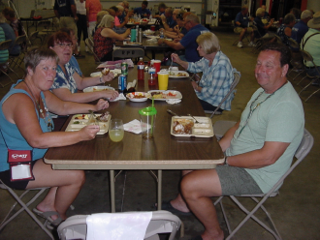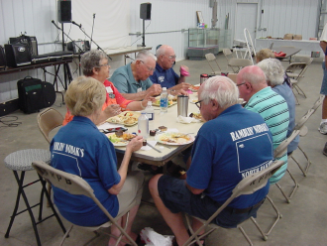
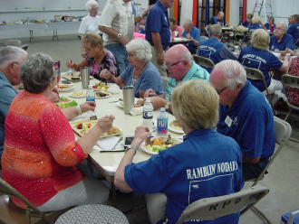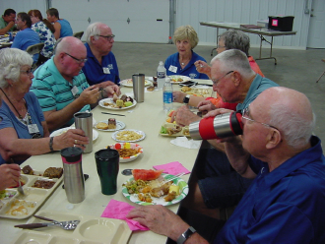
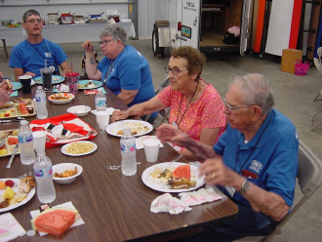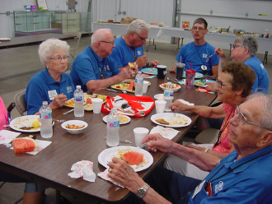
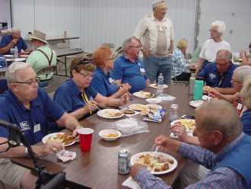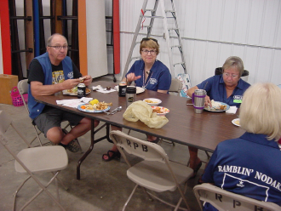
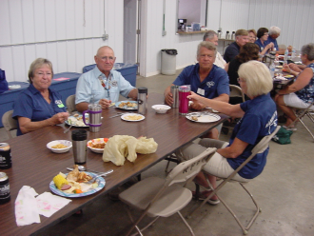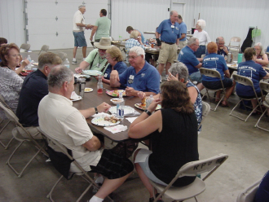
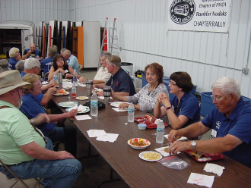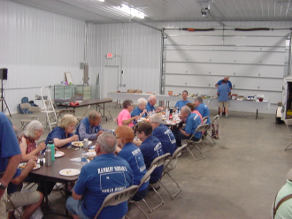

After Saturday’s tour of the impressive Pioneer Museum, ::
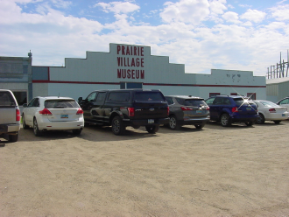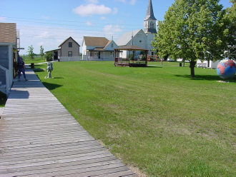
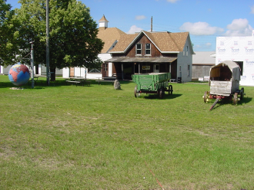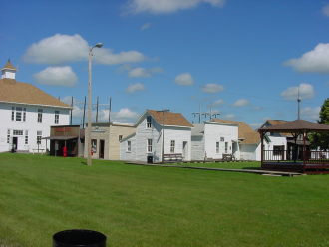

the highlight of the weekend was a pleasant evening at the Dakota Farms restaurant. A nice meal was followed by an open mike session during which everyone had a chance to share some of their favorite memories. The wrap to the evening was music provided by the “Spin Doctor”. With special dancers below:
Following Sunday’s breakfast and a meaningful worship service, the RV’s departed to their separate corners of the world. By their presence, everyone contributed. Thanks to Gary & Glenda Milner, several charter members, previous members, and current members. We are ready for another 25 years!

Financial Report to follow on next page:

Financial Report |  | 23 July 2019 | Year to date
INCOME:
 | Dues | 140.00 | 350.00
 | Travel Fund | 70.00 | 165.00
 | Books |  | 40.00
 | Bank interest |  | 1.29
 | Tip Jar-6 man golf carts*
Rally Income:
 | Mandan 2019 |  | 862.00
 | Hawks Museum 2019 |  | 150.00
 | Rugby 2019 | 2201.67 | 2201.67
 | Minot 2019 International Rally
 | Bismarck Sept 2019
 | TOTAL INCOME | 2411.67 | 3769.96
EXPENSES:
Rally Expense: | Mandan 2019 |  | -757.85
 | Hawks Museum 2019
 | Rugby 2019 | -2006.98 | -1706.98
 | Minot 2019 International Rally
 | Mandan Sept 2019
TOTAL Rally Expense
Office Expense | Postage, Supplies |  | -120.60
Club Supplies | Coffee, paper plates, cups, etc. |  | -47.10
Trailer | License, insurance |  | -36.00
Web Site: |  | -218.95 | -218.95
Donation/Memorials |  | -250.00 | -1600.00
Delegate Reimbursement
Misc Expense
 | TOTAL EXPENSES: | -2475.93 | -4487.48
 | Beginning Balance | 3285.89 | 3939.15
 | TOTAL INCOME | 2411.67 | 3769.96
 | TOTAL EXPENSES | -2475.93 | -4487.48
 | Bank Balance 07/01/19 | 3221.63 | 3221.63
 | Deposit/Checks not cashed* | -197.34
 | Ramblin NoDak's balance | 3024.29
 | Checks not cashed*
 | Deposit | 440.00
 | Donations | -300.00
 | Rugby expense | -337.34
 | Outstanding | -197.34

First notice of 2020 Dues for The Ramblin’ NoDaks

Please send $15.00 for the 2020 dues to:
Karen Grimm
410 1st Ave
Hickson, ND 58047-5136
Those who have not paid are:

Baumann | Hepworth | Roed
Beckman | Hodgson | Rutledge
Borowski | Hoff | Schmidt
Brackin | Hoffer | Sigurdson
Burdeniuk | Jaeger, George | Sommers, Bill
Cohn | Jaeger, Keith | Sommers, Mike
Cooper | Johnson | Sperbeck
Eckenrode | Kitzan | Swenson
Fritz | Leier | Trampe
Harrington | McMillian | Wilz
Heinle | Morgan | Wood
Heinrich | Richard
Hellman | Ringland

Some Lucky winners of Garda Hoirup’s hand embroidered dishtowels
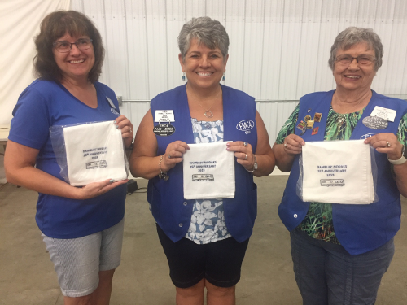

100th Anniversary International Convention
Minot, ND
Ramblin’ NoDaks Update

Attached you will find the Volunteer sheet and also the Caravan sheet. If you have information that is different, please contact me immediately so we can get it straightened out.

There has been a change in our gathering place. We will NOT be gathering in Surrey but on a frontage road right on the east side of Minot. Meeting time that you must be there to get your caravan credentials is 8:45 AM on Monday August 12th. Those coming from the Gunter Honeybee Farm will caravan to that spot. The meeting place will be on Hwy 2 – 1 block west of the 55th St traffic light. Turn north and then west onto the frontage road. We will line up there, put our caravan credentials on the windshield and caravan into the holding area. Darel has been working on this and has it figured out! Thanks Darel!

Volunteer meeting will be held on Tuesday August 13th at 9:00 AM in the Commercial 1 building or Seminar 9 building (west of the grandstand).

Thanks again and if you have any questions, please contact me: Pam Meier 701-440-1189

MANDAN SEPTEMBER RALLY
SEPTEMBER 5-8
Racing Assoc Campground 2500 Long Spur Trail Mandan,ND
Mtg room-Midway Lanes, 4696 (3327) Memorial Hwy, Mandan
26 Campsites have been reserved at $27/night with 50-A service
WITH FIRST 10 GETTING FULL HOOK-UP SERVICE
Annual Elections Hosts: Swenson’s, Hellman’s

Thursday: Arrive and park, supper on your own, evening of visiting

Friday Events:
Breakfast

A tour at Standing Rock at 10:30am (Line up at 9:30) and a stop at Prairie Knights Casino for lunch on your own and relaxation after the tour in Fort Yates.

The PowWow is also taking place on Friday and Saturday in Bismarck. Entry fee is free for over 65yrs of age.

Friday Night Pulled Pork Sandwiches with pot luck additions
Games and Visiting

Saturday Events:
Business Meeting at 9am with election of Officers

A possible tour of Shane Balkowitsch “Wet Plate Ambrotype Photography Studio” in Bismarck at 2703 Big Sky Circle.

Tour of the Governor’s Mansion on 4th and Ave B in Bismarck.

Heritage Center could follow Governor’s Mansion tour.

Saturday Night Chili Feed with “Just Desert” pot luck

Sunday: Breakfast & Church

REGISTRATION
MANDAN SEPTEMBER RALLY
5 - 8 SEPTEMBER 2019

Rally fee per coach $ 5.00

Building-use Fee per coach $ 10.00

Racing Assoc Campground fee $81 3 nights $________

Breakfasts (3) $10.00 per person x _____ $ ________

Dues $15.00 (if you need to renew) $ ________

TOTAL $ _________

Name ________________________________________________

Send registration to: Karen Grimm
410 1st Ave
Hickson,ND 58047-5136

PH: 701/371-3093 by AUGUST 29, 2019

