Ramblin Nodaks
NEWSLETTER 3 November 2018 uly 2018
W O R D S F R O M T H E P R E S I D E N T ‘ S D E S K
Hi Ramblin’ NoDaks (RNDs). Another year is nearly in the books. And, it has been an excellent year. We’ve been very busy (almost more activities than we could attend) and the RNDs club has been blessed with great new members. This year’s rally hosts have put on some superb rallies. Many of you have helped to make my work easier. I especially would like to thank Becky and Pam for all the help they have provided. Also, a special thank you to John & Garda for their exceptional work in keeping us informed via the newsletter, to Margaret for her efforts with our new tri-folds, and to those of you who I was able to lean on for advice.
MEMBER VOTE: FMCA is again requesting your vote on two important issues which can be reviewed on pages 36 & 37 of the October member magazine and again on pages 88 & 89 of the November magazine. The proposed changes are to increase the flexibility of the governing board in handling future elections and potential refunds. Please take a few moments to vote on these issues (one vote per FMCA number).
FMCA 100TH INTERNATIONAL CONVENTION: As you all know, next year’s milestone 100th International Convention will be held at the North Dakota State Fairgrounds in Minot, ND (our backyard) on August 14-17. FMCA officials promise to make this 100th event extra special. They will be counting on us to serve as volunteers in many areas. Registration begins on February 13th, 2019. It is critically important to register on time to get the kind of services you desire. Mark this important date on your calendars! [Note: This will also serve as the Midwest Regional Rally and the RMDs Rally for August] (SAVE THESE DATES)

2019 RNDs RALLIES: Rally plans for next year are nearly complete.
May 2-5 Midway Lanes, Mandan, ND Bill & Becky Sommers
Jun 6-9 Hawks Museum, Wolford, ND No Host
Jul 11-14 Fairgrounds, Rugby, ND Gene & Karen Grimm
(RNDs 25th Anniversary Gala) [SAVE THESE DATES]
Aug 14-17 100th International Conv.-Minot FMCA
Sep xx-xx Open (Please call)
(continued)
TRI-FOLDS: We have a powerful new tool in our arsenal. Some of you already have some in your possession. This mighty midget document contains club pictures, a “mission statement”, a rally schedule, a membership application, and contact information for club officers. When you encounter someone who you think might be a good future member, hand them one of these trifolds. It can be a useful tool to help begin a conversation about the RNDs, and is something that they may see at a later date and decide to give us a try!
A final reminder: Please review your RNDs pictures from the last 25 years and send your favorites to Darel Harrington. Darel has taken on a hugh job in putting together a slide show for the big event in July. He will need a lot of lead time to prepare this program, so he needs your input NOW! (That message is aimed at me also).
And so we wish you all safe travels this winter “weather” you are heading to a warmer climate or challenging the roads in this more adventurous area.

Respectfully submitted,
Gene Grimm, President of the Ramblin’ NoDaks

2018 Ramblin NoDaks Bank Report |  | From 10/01/17 to 10/31/18
INCOME:
Dues |  | 410.00
Dues – new member (10) |  | 200.00
Travel Fund |  | 475.00
Books |  | 70.00
Bank interest |  | 1.48
Tip Jar-6 man golf carts* | 1338.50 |  | see below
(to be donated to youth groups)
Total income from dues etc. |  | 2494.98
Rally Income:
Mandan 2018 |  | 610.00
Hawks Museum 2018 |  | 60.00
Spearfish/Gillette 2018
Minot 2018 |  | 715.00
Hazen 2018 |  | 1791.00
Total rally income: |  | 3176.00
TOTAL INCOME |  | 5670.98
EXPENSES:
Rally Expense:
Mandan 2018 |  | -629.45
Hawks Museum 2018
Spearfish/Gillette 2018 |  | -300.00
Minot 2018 |  | -840.00
Hazen 2018 |  | -1896.71
Ruby 2019 (July 2019) |  | -300.00
TOTAL Rally Expense |  | -3966.16
Office exp Postage, Supplies |  | -44.77
SuppliesCoffee, paper plates, cups, etc. |  | -358.58
Trailor – License, insurance |  | -28.00
Web Site: |  | -235.95
Donation/Memorials |  | -251.00
Delegate Reimbursement
Legal
Total Misc Expense: |  | -918.30
TOTAL EXPENSES: |  | -4884.46
Begining Balance | 3057.08 |  | as of 10/01/17
TOTAL INCOME |  | 5670.98
TOTAL EXPENSES |  | -4884.46
Bank Balance 10/31/18 |  | 3843.60
Tip Jar-6 man golf carts* | -1338.50 |  | (to be donated to youth groups)
Ramblin NoDak's balance |  | $2,505.10

Those who have not paid their 2019 dues.
Dues are due before 12/31/2018.
Please send $15 in US Dollars to:

Karen Grimm
410 1st Ave
Hickson, ND 58047

Those who have not paid are:

Darrell & Sherrie Borud
Verlyn & Brenda Cohn
Paul & Kathleen Hepworth
Garry & Terry Hiebert
Keith & Sandra Jaeger
Mike & Mary Kuchenski
Mike & Char Kuss
Mac & Janet McMillan
John & Jeri Morrow
Bryan & Dale Paquin
Larry & Leone Roth
Sharon Sigurdson
Arnold & Virginia Widmer
Greg & Sharon Wilz

6 MAN GOLF CART DONATIONS FOR YOUTH ORGANIZATIONS: (a program instituted by Larry Grindy at the Minot Host Fest 2018)
Several members drove 6 man golf carts. $1338.50 was raised in tips. This money is to be given to youth organizations. The money is in the Ramblin NoDaks account and it is our responsibility to administer the funds. Please send me suggestion of organization in your community that we could support. Some suggestions are: Annie's House, Boys and Girls Clubs, The Minot Gun Club youth programs and Mandan Bowling Alley youth program. Include North Dakota, South Dakota, and Canada.

Note from John Emmett:

I don't know if you all received or read the FMCA INTO Area newsletter, but I found the following to be of special interest to all Rambin' Nodaks and Canadian Northern Lights. Here is the proposed schedule for International Rallies for next several years.
Aug 14-17, 2019 100th International Conv.-Minot FMCA
Winter 2020 Tucson, Arizona-Pima County Fairgrounds
Summer 2020 Rock Springs, Wyoming
Winter 2021 Perry, Georgia
Summer 2021 Gillette, Wyoming, or St. Paul, Minnesota
Winter 2022 Tucson, Arizona
Summer 2022 Rock Springs, Wyoming
Winter 2023 Perry, Georgia
Summer 2023 Sedalia, Missouri, or Gillette, Wyoming
Summer 2024 Syracuse, New York

IMPORTANT 2019 RALLY INFO
The following national rally information was passed on to me by MAC President Gary Milner. Some of you may already be informed of these updates regarding 2019 national rallies.

SUMMER RALLY: This is exciting news for the Ramblin' NoDaks (and the Northern Lights). FMCA's milestone 100th national rally will be held in Minot, ND during August of 2019. This means that the MAC subdivision of FMCA will be the hosting unit. Several hundred volunteers will be required to stage a successful event. The RAMBLIN' NODAKS unit can play a major role in the success of the Minot convention. There are many chapter members who were involved with FMCA's previous Minot rally which took place in approximately 2005. Also, many members currently serve as volunteers at the Hoostfest (the nations largest Scandinavian festival) at the Minot facility. Please forward to me any suggestions that you think could make the upcoming Minot Convention run more smoothly. MAC President Gary Milner and national rally planners at FMCA's home office will be invited to attend the Hoostfest to observe parking and other event operations at that large scale fall festival.

Best regards,
Gene Grimm, Ramblin' NoDaks MAC Rep

FROM OUR NORTHERN NEIGHBORS:
The first Rally of 2019 will be at the Carberry Ag grounds in Carberry, Manitoba , May 23rd to 26th. The facility has been booked and our hosts will be Kevin and Louise Champagne and George and Margaret Jaeger. Thank you to these two couples for stepping up to organize a weekend for us and let's support their success by making every effort to attend the Rally. At this Rally we will be discussing what we can plan for up coming years, and any suggestions will be appreciated. If you are planning to attend the Carberry Rally please contact either of the hosts no later than May 1st, 2019.
Jaegers-----204-466-2882 Champagnes-----204-275-0183
In 2019 the FMCA 100th International Convention & RV Expo will be held in Minot, North Dakota August 14th-17th, 2019. Registration for the convention will open in
February 2019. I know that the Ramblin Nodak's are looking at volunteering at the convention and would much appreciate all the support they can get from the Canadian Northern Lights group. Several couples from the Canadian Northern Lights attended the Gillette , Wyoming convention this year and truly enjoyed their time at the convention as well as volunteering with the Nodak's. The knowledge that is shared at these conventions, as well as the entertainment that is booked is truly amazing. Also Ken Johnson has made mention that he is working on a get together in Moose Jaw at their 2019 Air Show. The Air Show will held July 5th, 6th, & 7th 2019.
If you require any further information on these events please feel free to contact myself or any of the executive and we will do our best to get the information you require.
As we all prepare for winter in our own ways, some will be heading South to warmer climates. Hopefully their trip will be safe and uneventful. Dale and I will be in
Casa Grande, Arizona again this year and if anyone is driving by please feel free to contact us, to get together for a visit.
We wish everyone good health and safe travels and we are looking forward to seeing everyone in the Spring.
Your Editor
Bryan Paquin

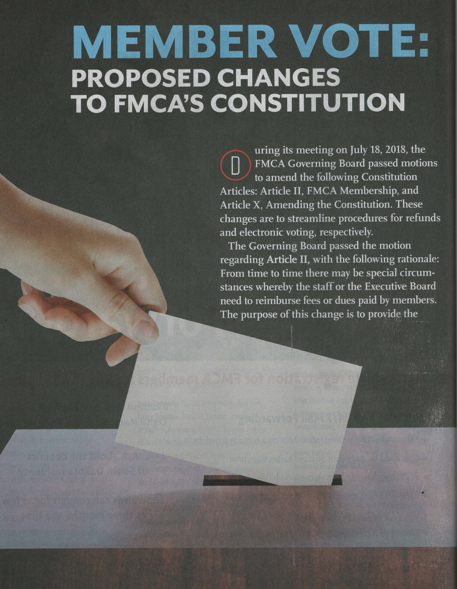
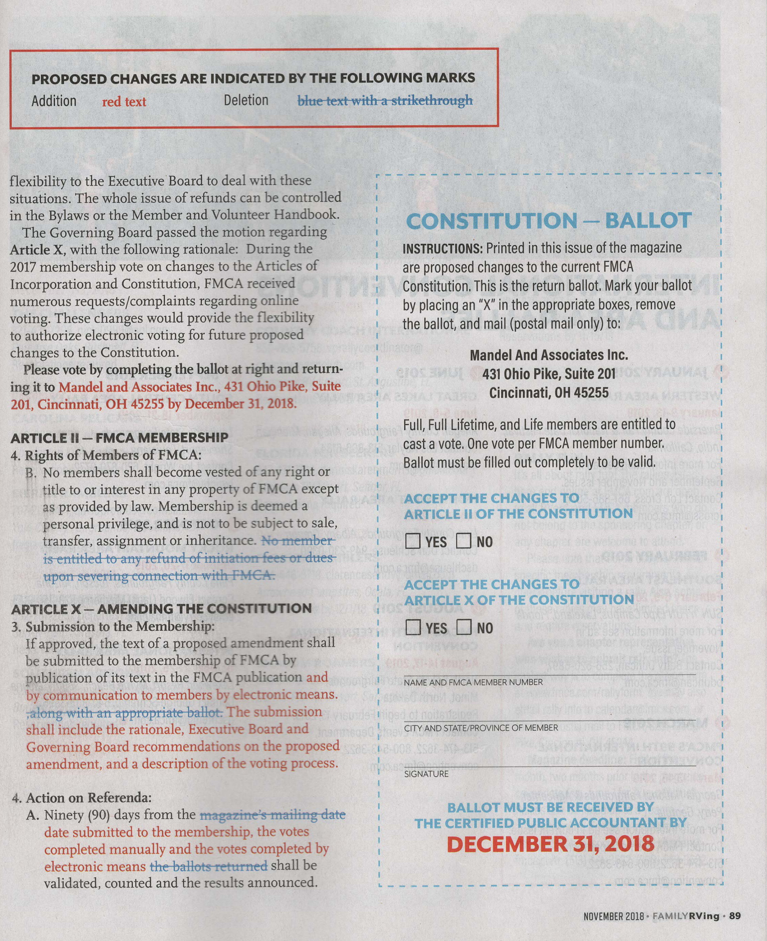

Subject: FMCA Information

If you need to update your e-mail address, phone numbers, etc. with FMCA you must do this at the FMCA website below. You may need to create an account to change your personal information with FMCA. If you have problems call FMCA at 1-800-543-3622.

https://site.fmca.com/
Go to Log In at top of page: If you do not have an account you may have to create an account.
Once you are logged in go to the right side of the page and click on profile.
Make sure all your information is correct. Our chapter cannot correct your information and you must do your own corrections with FMCA. Thanks for your help to keep the information of your profile up to date with FMAC.

Attached is a new copy of the Members of Ramblin’ NoDaks. Please verify that your information is correct. Have a wonderful winter in the snow or sunshine, see you all in the Spring, John & Garda

