Ramblin Nodaks
May 2018

Hi Ramblin; NoDaks:
We really enjoyed the Mandan rally last weekend. Thanks Becky & Bill, Mark & Donna, and Ernie & Francis for putting on a great event. Despite a tour cancelation, everything rolled along quite smoothly. It is always a great pleasure seeing everyone again after the long winter lay off. Also, meeting and getting acquainted with new members Dave & Sandy Eckenrode and Charlie and Ginny Swenson was rewarding.
Next June will mark the 25th anniversary of the Ramblin’ NoDaks. John Emmett, Darel Harrington, and Gordy Wettlaufer agreed to serve on a committee to plan a special June 2019 rally to commemorate this momentous milestone. By putting our heads together, we will be able to make this a meaningful event. Have you been a part of such an event with other organizations? Please make a personal commitment to present some suggestions to this committee.
I know this sounds too incredulous to believe, but Karen and I rode home to Hickson on Sunday morning pushed by a “tail wind”. During the short stay at home, we were able to get the lawn and ditches mowed and worked in two doctor appointments before hitting the road to Indianapolis on Tuesday morning. The weather was not our ally on this trip as we encountered high winds (from all directions), lightning, thunder, heavy rains, as well as road construction. I was sure that the motorhome had never before had so much wind noise. Finally the reason became apparent: Most of the screws holding the driver’s side window assembly were all backed nearly all of the way out. The window could easily have been pulled from the motorhome. But that trip was completed and we are parked across the street from the Indianapolis Motor Speedway in an old mobile home park ready to watch the Indy Cars race on the road course Saturday May 12th and on the big 2 ½ mile oval for the 102nd running of the Indy 500 on May 27th. It will be my 50th year at the race and Karen’s 49th. That seemed like a lot of years; however, I talked to a friend last night who will be at his 74th Indy 500. I’m sure there will be many 90 year old locals here who have attended the race since they were perhaps 3 years old.
So, we will be back in North Dakota just in time for more lawn mowing (and more doctor appointments) before heading to the Wolford (Hawks Museum) Rally. We look forward to seeing those of you who can make it there on June 7-11. That promises to be a fun event. Safe travels to all. Gene G

REGISTRATION FOR WOLFORD

The schedule of events for the Hawks museum has been enclosed with the newsletter, but I have a couple of additions to make.
Camping will be $30.00 total for all three nights. Admission to the events will be a button that we buy for $10.00 each for all 3 days.
There is a breakfast on the grounds. It is inexpensive and very good. Usually they serve pancakes and sausage with juice and coffee.
Friday night is a BBQ rib supper on the grounds. We thought we would have a pot luck supper that night (5:00) for those that want to get together at the campground. Saturday night is Prime Rib supper on the grounds and that night we will have a “bring your own meat to grill and one dish to pass” at the campground (6:00) for those that want to do that. These are optional for everyone but we wanted to have some plans if you don’t want to eat on the grounds. The noon meals will be on your own.
There will be a short informal meeting @ 2:00 Friday afternoon @ the campground!
Please send registration to: Becky Sommers 2214 Harding Ave Bismarck ND 58501 or call 701-258-8854 or email to : bsommers @bis.midco.net before May 30th. Make your check payable to Ramblin’ NoDaks for the rally fee.

Name______________________________________________________________
Rally Fee: $5.00

**************************************************************************

Long ago when men cursed and beat the ground with sticks, it was called witchcraft.
Today it is called GOLF!

Life is like a roll of toilet tissue….the closer it gets to the end, the faster it goes!

It’s not your altitude, but your attitude that makes you soar!

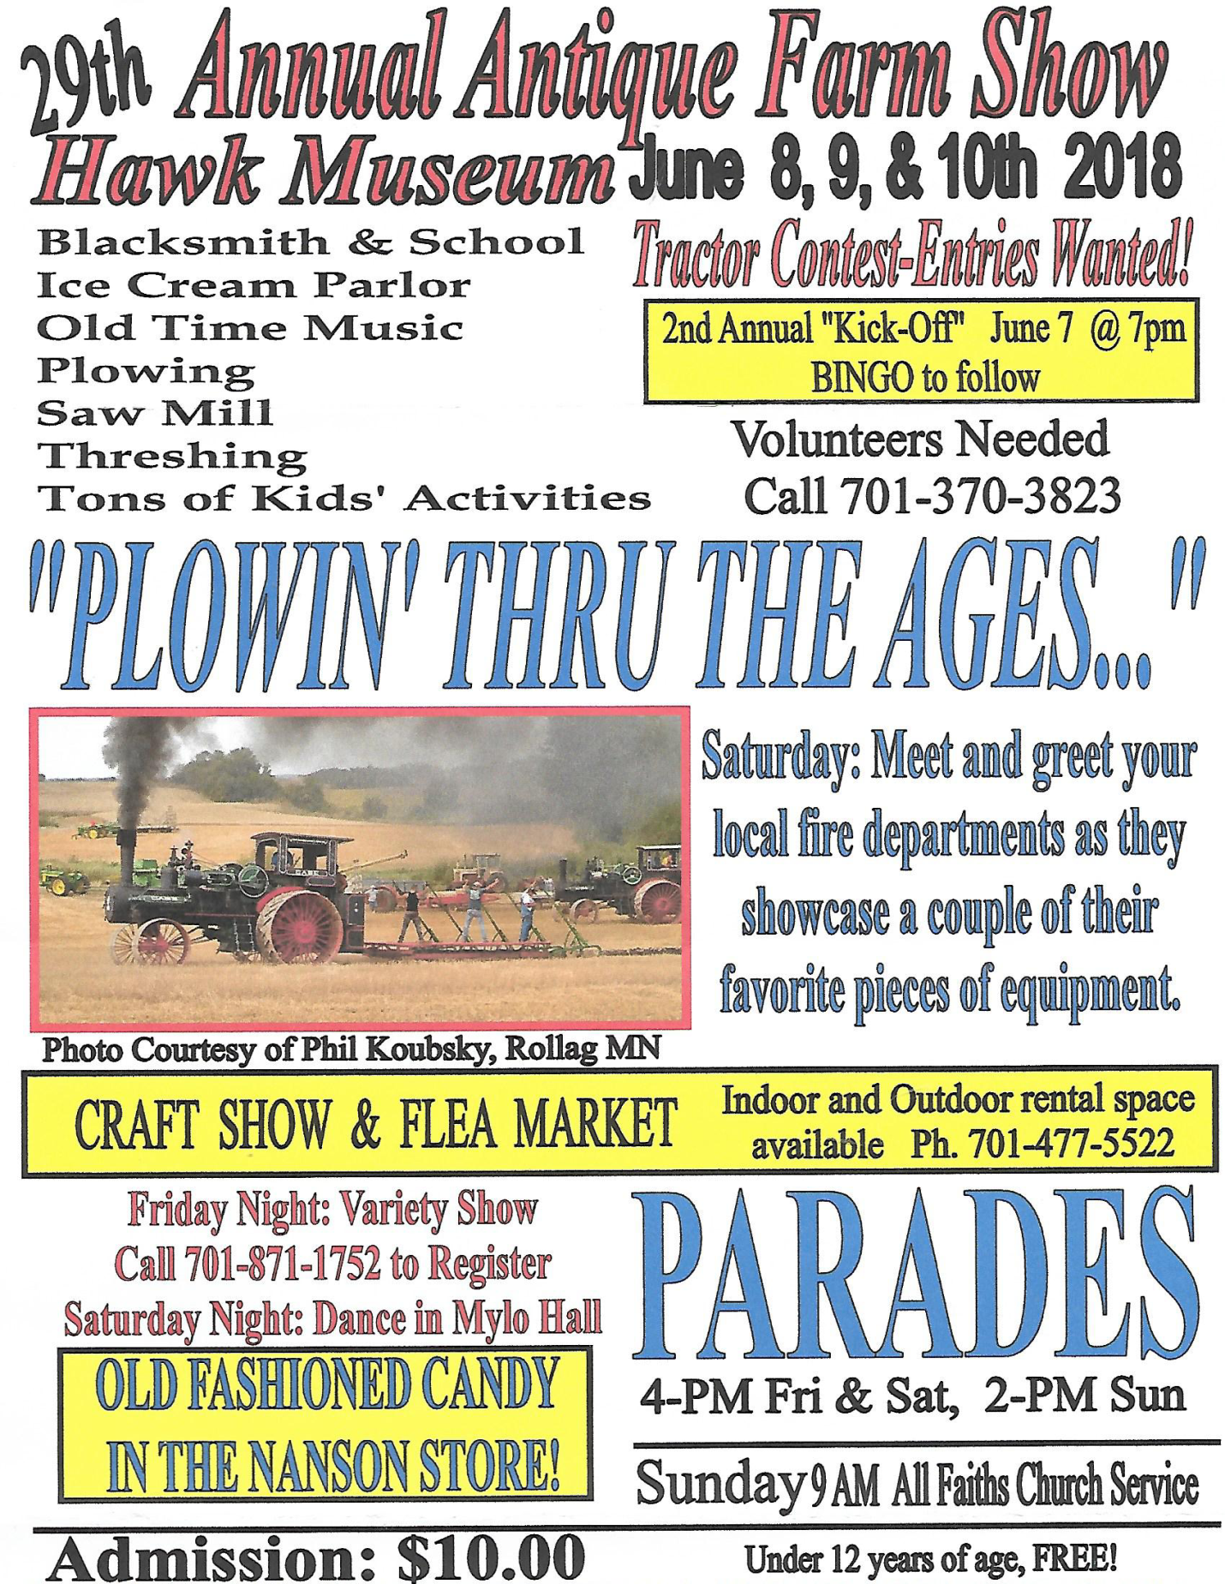

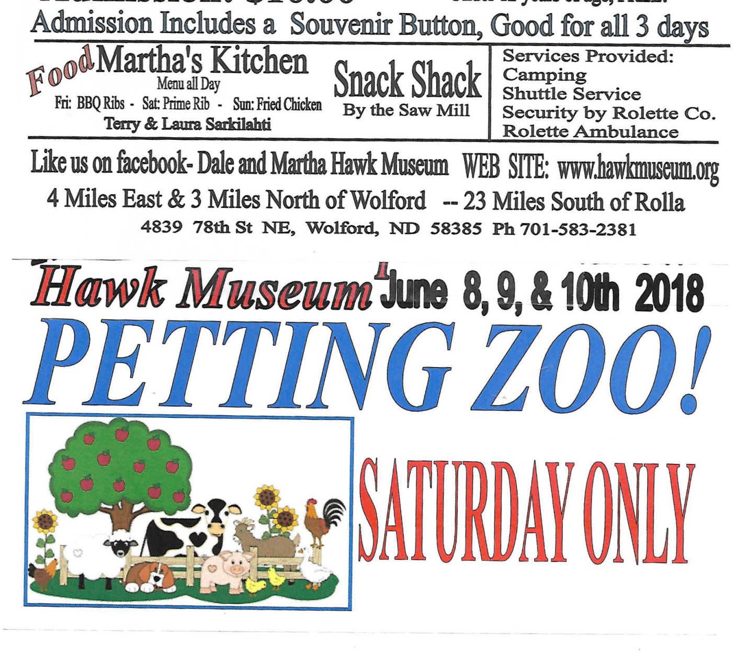
*******************************************************************************************************

IMPORTANT 2019 RALLY INFO
The following national rally information was passed on to me by MAC President Gary Milner. Some of you may already be informed of these updates regarding 2019 national rallies.

SPRING RALLY: The intent was to hold the rally in Chandler, AZ, however before the contract signatures were in place, the facility raised the event price by $100,000. Other venues considered were Las Vegas (also too expensive) and Tucson, AZ (desired dates not available). The decision was made to return to Perry, GA in March of 2019.

SUMMER RALLY: This is exciting news for the Ramblin' NoDaks (and the Northern Lights). FMCA's milestone 100th national rally will be held in Minot, ND during August of 2019. This means that the MAC subdivision of FMCA will be the hosting unit. Several hundred volunteers will be required to stage a successful event. The RAMBLIN' NODAKS unit can play a major role in the success of the Minot convention. There are many chapter members who were involved with FMCA's previous Minot rally which took place in approximately 2005. Also, many members currently serve as volunteers at the Hoostfest (the nations largest Scandinavian festival) at the Minot facility. Please forward to me any suggestions that you think could make the upcoming Minot Convention run more smoothly. MAC President Gary Milner and national rally planners at FMCA's home office will be invited to attend the Hoostfest to observe parking and other event operations at that large scale fall festival.

Best regards,
Gene Grimm, Ramblin' NoDaks MAC Rep

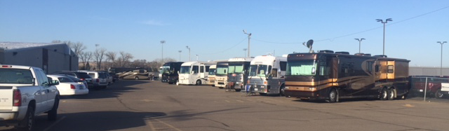
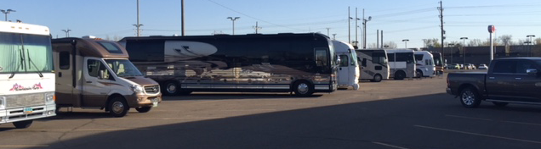
Photo’s from Mandan Rally

May 5, 2018 Meeting Minutes
9:00 am
President Gene Grimm called the meeting to order. A quorum was determined and the meeting proceeded. The pledge was said.

President Grimm introduced five new members. He welcomed Dave and Sandy Eckenrode, Charlie and Ginny Swenson, and those not present were: Mike & Charlene Kuss, Paul & Kathleen Hepworth, and Greg & Sharon Wilz. There were no guests present.

President Grimm thanked the rally hosts, Fritz, Morgan and Sommers and also thanked John and Garda for a great job on the newsletter.

Secretary Becky Sommers read the minutes of the last meeting in Aberdeen and they were approved as read.

Treasurer Karen Grimm passed out the treasury report and it was approved.

Gene Grimm gave a MAC report and stated the MAC convention would be in Amana, IA on August 8-11.

The Ramblin’ NoDaks received a thank you note from Butch Wood.
A formal invitation was sent to Gary Milner, MAC President, to come to the rally at Hazen Bay.

Pam Meier reported on the vote for the towables to be accepted into the Ramblin’ NoDak chapter. We needed 65% of the membership voting and we got 77%. The outcome was 37 yes votes and 1 no vote. The by-laws have been brought up to date.

On June 4, 2019 our club will be 25 years old. We will start working on the events for the occasion. A committee was put together for the planning. The committee consists of John Emmett, Gordy Wettlaufer and Darel Harrington.

At the Gillette rally they are having problems getting our group to be able to park together. John Emmett said that Gillette had over sold the 50 amp service and this created the parking problem. Pam was assured by the event coordinator that the coffee people would be able to be in a special parking area. At this time it is not sure.

Becky Sommers presented a clock to Pam Meier to be given to past president John Meier for all of his hard work that he did for the Ramblin’ NoDaks during the last 4 years. John was not able to attend this rally.

President Grimm requested that everyone put phone # in their contact list for the officers so it will be easier to keep In touch with them.

President Paquin of the Canadian Northern Lights needs a head count for their 25th anniversary which will be in Carberry MB on May 24-27. You can reply by e-mail.

We still need rally hosts for 2019. Sommers will take the May 2-5 rally in Mandan. If you can host please contact Gene.

The next rally will be In Wolford ND @ Hawks Museum June 7-10. This will be a no host rally.

The Pre Rally going to Gillette will be held at the Elk Heart Resort July 13-15, then caravan on to the National Convention on July 16. After the convention Ken Johnson has put together a rolling rally into Canada leaving on the 22nd and going until the 30th.
Darel Harrington stated that there was a date change for the Minot rally at the Air Force Base. The rally will be the 2-5th of August.
John Emmett gave a report on the Perry Georgia rally that they attended this spring.
Becky Sommers will check with the national office to see if there are still door hangers available to give to RV dealers as they sell towables to encourage them to join FMCA.

There was a drawing for the sheriff’s kitty and it went to Becky Sommers. There was $27.00 and change in it.

Door prizes were awarded and the meeting was adjoured.
********************************************************************************************************
2018 Ramblin NoDak's Bank Statement
From 05/01/18 to 05/14/18

Income:
Dues: 2019 40.00
Travel Fund 20.00
Total Fund 60.00
Rally Income:
Mandan 2018 630.00
Total Rally Income 630.00

Total Income .................................................................. 690.00

Expenses:
Club Supplies
Coffee, paper plates, etc -87.67
Total Club Supplies -87.67

Office Expense
Postage, Supplies -127.72
Total Office Exp -127.72

Trailer Expense
Insurance -8.00
License -20.00
Total Trailer Exp -28.00

Total Expenses:.................................................... -703.62

Balance as of 05/01/18 3241.34
Total Expenses - 703.62
Total Income 690.00
Balance as of 05/12/18 $3227.72

Total travel Fund 310.00

