Ramblin Nodaks
NEWSLETTER 8 April 2019 uly 2018
W O R D S F R O M T H E P R E S I D E N T ‘ S D E S K
Words from the President April 2019 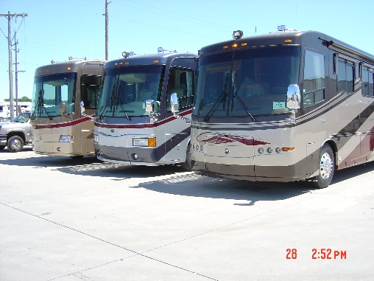
Greetings Ramblin’ NoDaks. Spring has returned, and it is time to get those coaches shined and ready for another exciting season. We welcome new members Edward and Phyllis Hodgson as well as returning members Charlet Sperbeck and Klaus & Lavergn Trampe. There are still a few who have not paid 2019 dues.
It will be difficult to top the quality of last year’s rallies, but the new line up will be special indeed.
May 2-5
Mid-Way Lanes Mandan,ND Hosts: Bill & Becky Sommers
(Mid-Way Lanes Rally Registration form is attached)

Charity(s) to be selected (AT THE MANDAN RALLY) to receive monies earned at Hostfest in 2018 regarding “TIP JAR-6 MAN GOLF CART DONATION FOR YOUTH “

6 MAN GOLF CART DONATIONS FOR YOUTH ORGANIZATIONS: (a program instituted by Larry Grindy at the Minot Host Fest 2018)
Several members drove 6 man golf carts. $1338.50 was raised in tips. This money is to be given to youth organizations. The money is in the Ramblin NoDaks account and it is our responsibility to administer the funds. Please send me suggestion of organization in your community that we could support. Some suggestions are: Annie's House (Bottineau), Boys and Girls Clubs, The Minot Gun Club youth programs (Minot), Mandan Bowling Alley youth program(Mandan) and the Peace Garden Music Camp (No Dak/Canada). Include North Dakota, South Dakota, and Canada.
June 13-15 [NOTE NEW DATE]
Hawks Museum Wolford,ND No Host Event
Relaxed weekend with unlimited things to see and do
Even homemade pies including June Berry (my favorite)

July 11-14
Rugby Fairgrounds Rugby,ND Hosts: Gene & Karen Grimm
SPECIAL 25th Anniversary Event! Special Music provided
Sit-Down dinner MAC President Gary Milner to attend
Darel Harrington still needs pictures, stories, etc of the past

Aug 14-17
100th International Convention Minot, ND
We are the host club and will serve coffee and donuts
Chapter & Regional Mtgs during event
Pre-Rally gathering at Dick & Alice Gunters (details later)

Sept 12-15
Hosts needed for this event Please step up!
Elections will be held

The 2020 rally schedule will be set up soon. We need your services to host an event. If you are new in the club, there are veterans who are available to give you a hand. A fresh outlook is always good.
Look for our club rally schedule to be published in the May issue of Family RVing. There will also be an article on the RAMBLIN’ NODAKS.
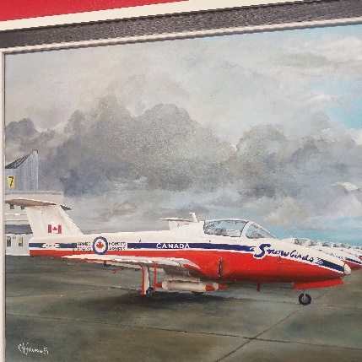 Canadian Snow Bird Plane, A great memory from a 2018 rally

Ken, Sam, & Mary Lou
Three Ramblin’ NoDaks members recently have lost courageous and lengthy battles with health issues. Ken Johnson (and Shirley) were returning home on a difficult journey after having visited Ramblin’ NoDaks in Arizona and Texas while former member Sam Sperbeck was unable to do any traveling for a lengthy period of time. Previously, Mary Lou Wood was lost after years of health issues. We all regarded Ken, Sam, and Mary Lou as family more than just club members. Our thoughts and prayers are with spouses Shirley, Charlet, Butch and members of their families.
There will be a celebration of life for Sam on May 18th from noon to 5 pm at the West River Community Center in Dickinson (2004 Fairway St). Service arrangements for Ken are pending. A service for Mary Lou was held March 17, 2018.

Respectfully submitted, Gene Grimm, President

Treasurer Report by - Karen Grimm  2019 Ramblin NoDaks Bank Report |  | From 10/31/18 to 004/01/19
INCOME:
 | Dues | 120.00
 | Dues – new member (10)
 | Travel Fund
 | Books
 | Bank interest | 0.79
 | Tip Jar-6 man golf carts*
 | (to be donated to youth groups)
Total income from dues etc. |  | 120.79
Rally Income:
 | Mandan 2019
 | Hawks Museum 2019
 | Rugby 2019
 | Minot 2019 International Rally
 | Sept 2019 ???
Total rally income:
 | TOTAL INCOME
EXPENSES:
Rally Expense: | Mandan 2019
 | Hawks Museum 2019
 | Rugby 2019 | -300.00
 | Minot 2019 International Rally
 | Sept 2019 ???
 |  | -300.00
TOTAL Rally Expense
Office Expense | Postage, Supplies | -74.39
Club Supplies | Coffee, paper plates, cups, etc.
Trailor | License, insurance
Web Site:
Donation/Memorials
Delegate Reimbursement
Legal
Misc Expense
 | TOTAL EXPENSES:
 | Begining Balance | 3939.15 | as of 10/31/19
 | TOTAL INCOME | 120.79
 | TOTAL EXPENSES | -74.39
 | Bank Balance 04/01/19 | 3985.55
 | Tip Jar-6 man golf carts* | -1338.50
 | Ramblin NoDak's balance | 2647.05

Members who have not paid 2019 Dues:
Darrell & Sherrie Borud
Gary & Terry Hiebert
Mike & Mary Kuchenski
Mike & Char Kuss
Bryan & Dale Paquin
Larry & Leone Roth
Arnold & Virginia Widmer

Respectfully submitted, Karen Grimm

***********************************************************************************

Reminder From Our Northern Neighbors:

The first Rally of 2019 will be at the Carberry Ag grounds in Carberry, Manitoba , May 23rd to 26th. The facility has been booked and our hosts will be Kevin and Louise Champagne and George and Margaret Jaeger. Thank you to these two couples for stepping up to organize a weekend for us and let's support their success by making every effort to attend the Rally. At this Rally we will be discussing what we can plan for up coming years, and any suggestions will be appreciated. If you are planning to attend the Carberry Rally please contact either of the hosts no later than May 1st, 2019.
Jaegers-----204-466-2882 Champagnes-----204-275-0183

************************************************************************************
Anyone that is planning to serve donuts and coffee in Minot, or caravan with the group, please be sure that you have sent that to Pam Meier. Thanks!

****************************************************************************
Attached is the updated Address & Phone Directory.

From the Director “Butch” Wood
