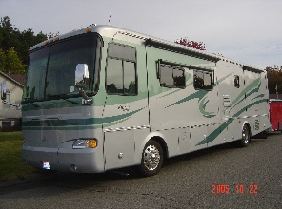
RAMBLIN’ NODAKS MONTHLY RALLY NOMINATION FORM
Nominated by _________________________________
Site ______________________ Nearest Town _______________________ State/Prov ______
Reservations Available? Yes __ No ___
Hookups: Water ___ Sewer ___ 50/30/20 ___ 30/20 ___ 20 ___ No Power ___ Dump Station Yes ___ No ___ Location of Dump _______________________
Sites: Paved ___ Gravel ___ Grass ___ Dirt ___ Level ___ Pull Through ___ Back In ___ (Mark one or more)
Club House Yes ___ No ___ Cost per event _____ Provisions of CH __________________
Preferred/Group Sites (# available) ________________________________________________
I have visited this site Yes ___ No ___ I will be the Rally Master Yes ___ No ___
Why I am suggesting this sight for a future RAMBLIN’ NODAKS Rally: ____________________

______________________________________________________________________________
Special area events or features that would enhance this rally site: ______________________
______________________________________________________________________________

Additional Comments: __________________________________________________________

______________________________________________________________________________-

